New AI learning things:
- Unsloth is an open-source framework/library used to train and fine-tune Large Language Models (LLMs) faster, with less GPU memory, and at lower cost.

Pre-trained LLM
↓
Unsloth
↓
Efficient Fine-Tuning
↓
Customized LLM
↓
Your Application
- Orchestration

Orchestration means coordinating and managing multiple components, tools, or processes so that they work together automatically to achieve a goal.
Simple example 🎯
Imagine you're building an AI application:
User
↓
AI Application
↓
Orchestrator
├──→ LLM
├──→ Database
├──→ API
├──→ Authentication
└──→ Notification Service
- LangGraph
LangGraph is a framework for building AI/LLM applications where multiple steps, decisions, and AI agents need to work together in a controlled workflow.
The easiest way to understand it is:
LangGraph lets you create a workflow for an AI system and control how the AI moves from one step to another.
🧠 Simple example
Suppose you're building an AI customer-support system:
User Question
↓
[Understand]
↓
Is it a billing issue?
↙ ↘
YES NO
↓ ↓
[Billing Agent] [General Agent]
↓ ↓
Check database Search knowledge
↘ ↙
↓
[Response]
↓
User
- DeepEval

DeepEval is an LLM evaluation framework used to test and measure the quality of AI applications.
Think of it like unit testing for LLM applications.
For a normal software program:
Input → Program → Output
↓
Unit Tests
↓
Pass / Fail
For an AI application:
Question → LLM/Agent → Answer
↓
DeepEval
↓
Is the answer good?
- Ragas

What is Ragas?
Ragas is a framework specifically focused on evaluating LLM and RAG pipelines.
RAG means:
Retrieval-Augmented Generation
User Question
↓
Retriever
↓
Relevant Documents
↓
LLM
↓
Final Answer
Ragas evaluates whether these stages are working properly.
- Data Curation:

Data curation means collecting, cleaning, organizing, checking, and preparing data so that it is useful and reliable for a particular purpose.
In simple words:
Data curation = taking raw data and making it clean, relevant, organized, and ready to use.
- CI/CD Framework:

What is a CI/CD framework?
CI/CD stands for:
CI = Continuous Integration
CD = Continuous Delivery / Continuous Deployment
A CI/CD framework is a set of tools and practices that automates the process of building, testing, and releasing software.
In simple terms:
CI/CD automatically takes your code from “developer writes it” → “tested” → “built” → “deployed to users.”
🔄 Basic CI/CD workflow
Developer writes code
↓
Push to Git
↓
┌───────────────┐
│ CI │
│ Build + Test │
└───────────────┘
↓
Tests pass?
↙ ↘
NO YES
↓ ↓
Fix code Build
↓
┌───────────────┐
│ CD │
│ Deploy/Release│
└───────────────┘
↓
Production

Questions:
1.How does the relevance grader node finds if the query and retrieved chunks are matching/correct?
2.
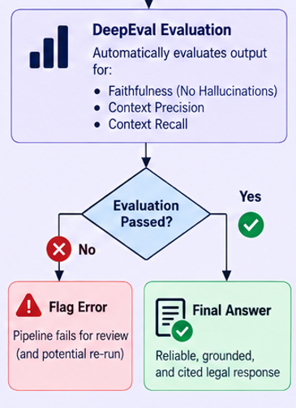
For this evaluation if the output has error what should be done?
should I run the entire pipeline again or should I fine tune the model
3.do literature survey properly.

